Part Number: PT747-07190
Kit Contents
Item # | Quantity Reqd. | Description
1 | 1 | Applique, RR Bumper
Hardware Bag Contents
Item # | Quantity Reqd. | Description
1
Additional Items Required For Installation
Item # | Quantity Reqd. | Description
1
Conflicts
None
Recommended Tools
Personal & Vehicle Protection | Notes
None
Special Tools | Notes
Squeegee | 4" (3M™Gold) or  4" (3M™Silver)
Low Friction Sleeve | 3M SA-1 (Optional1)
Surface Thermometer | Infrared Non-contact
Heat Gun | Master Heat Gun HG-301A or equivalent
Installation Tools | Notes
Lint Free Rags
Spray Bottle | For wetting agent
Special Chemicals | Notes
Cleaner | VDC approved cleaner and cleaning method
Wetting Agent  Note: Solution depends upon ambient temperature of the part and the vehicle surface. If it is difficult to remove bubbles with a squeegee, add one more ml. of shampoo. | Johnson’s Baby Shampoo mixed in one liter of water:  Temp Shampoo  65º F 2 ml  70º F 3 ml  80º F 3.5 ml  90º F 4 ml
General Applicability
MY19 and newer Avalon/HV vehicles
Recommended Sequence of Application
Item # | Accessory
1
*Mandatory

Vehicle Service Parts (may be required for reassembly)
Item # | Quantity Reqd. | Description
1
2
3
Legend
STOP: Damage to the vehicle may occur. Do not proceed until process has been complied with.
OPERATOR SAFETY: Use caution to avoid risk of injury.
CAUTION: A process that must be carefully observed in order to reduce the risk of damage to the accessory/vehicle and to ensure a quality installation.
TOOLS & EQUIPMENT: Used in Figures calls out the specific tools and equipment recommended for this process.
REVISION MARK: This mark highlights a change in installation with respect to previous issue.
SAFETY TORQUE: This mark indicates that torque is related to safety.

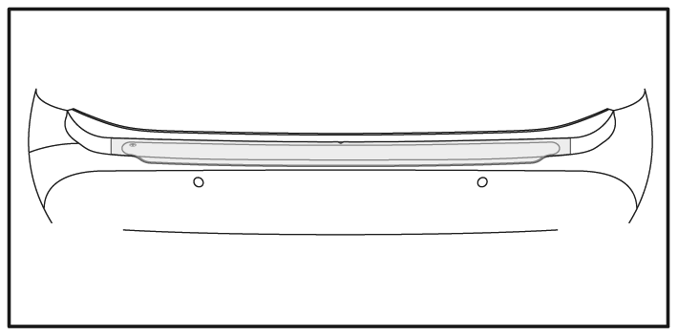

v
Care must be taken when installing this accessory to ensure damage does not occur to the vehicle. The installation of this accessory should follow approved guidelines to ensure
a quality installation.

These guidelines can be found in the "Accessory
Installation Practices" document.

This document covers such items as: -
• Vehicle Protection (use of covers and blankets, cleaning chemicals, etc.).
• Safety (eye protection, rechecking torque procedure, etc.).
• Vehicle Disassembly/Reassembly (panel removal, part storage, etc.).
• Electrical Component Disassembly/Reassembly (battery disconnection, connector removal, etc.).

Please see your Toyota dealer for a copy of this document.

STORAGE | 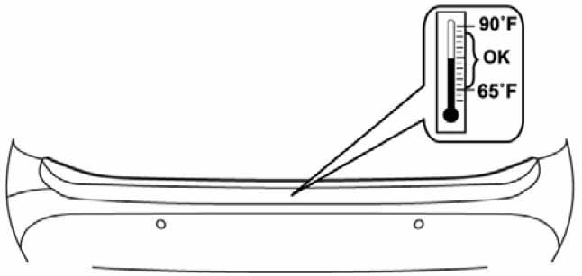  INSTALLATION TEMPERATURE | 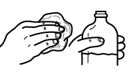  CLEANER |  | 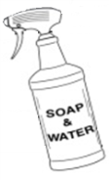
 |  | SQUEEGEE | SLEEVE  (OPTIONAL) | 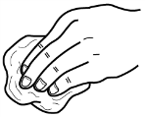  LINT FREE

REAR BUMPER APPLIQUE

1

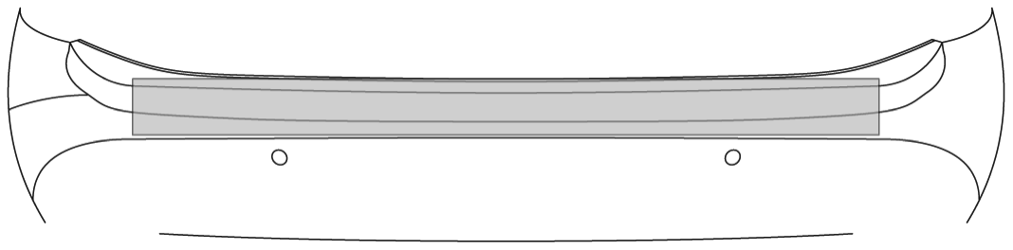
DRY
b
CLEAN
a

3
2

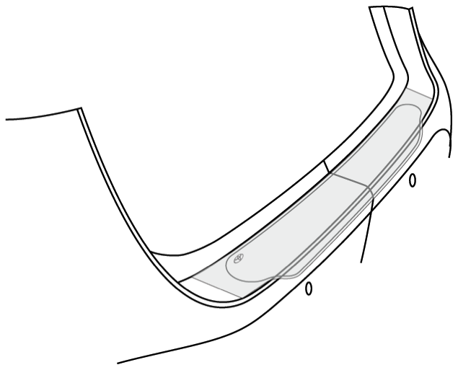
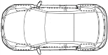

ALIGN
4

5

ALIGN

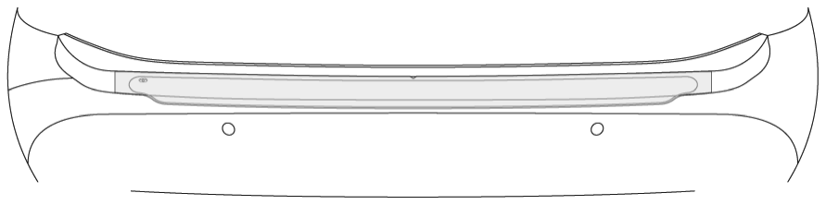

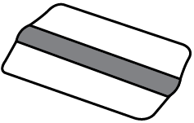

SQUEEGEE

SQUEEGEE
6

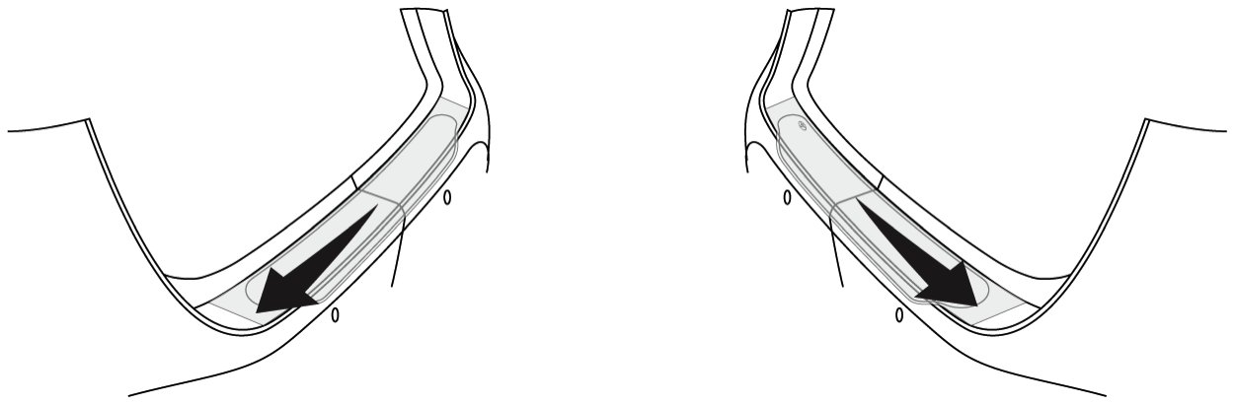

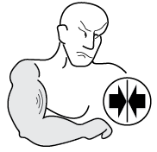

180°

PULL

7

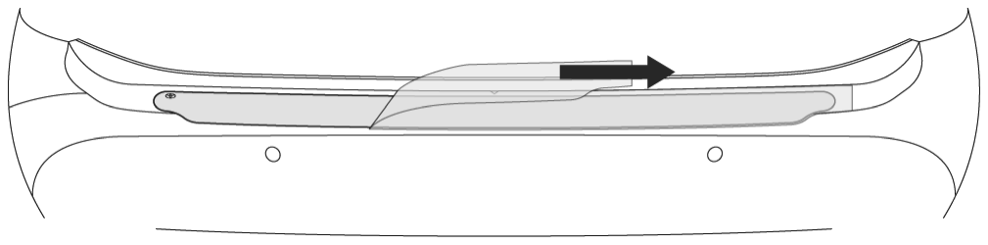

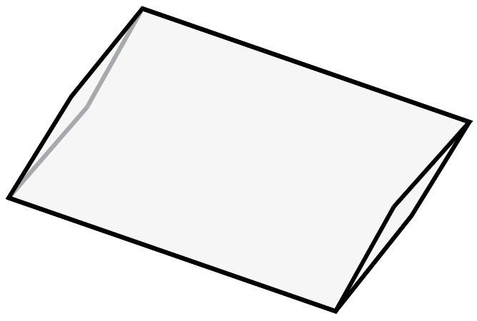
SLEEVE

8
= OPTIONAL

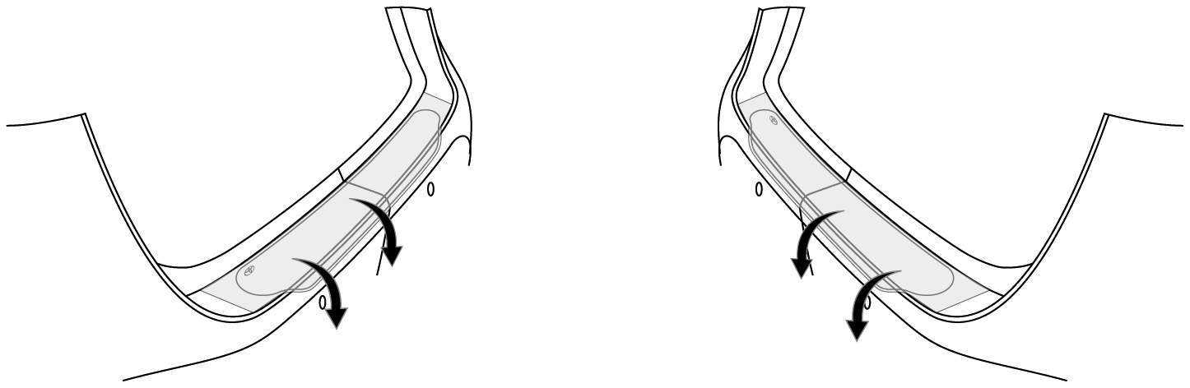
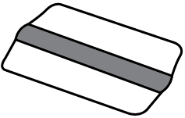

SQUEEGEE

SQUEEGEE

3
1
4
2

9
v

DRY

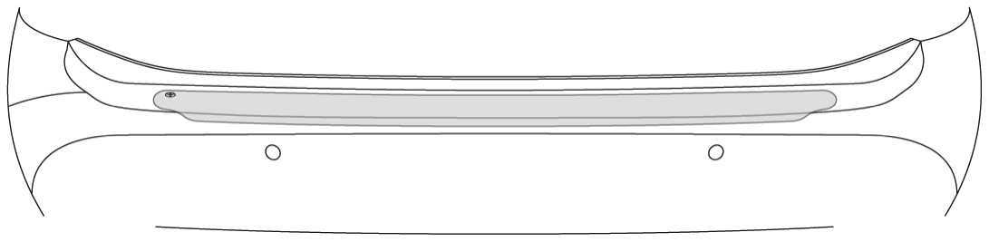

Accessory Function Checks
Proper adhesion – Visual
Proper adhesion – Physical

Proper alignment – Cross-Car

Vehicle Appearance Check
After accessory installation and removal of protective cover(s), perform a visual inspection.

Look for bubbles, loose and lifting edges.
With light pressure rub hand over top of part and if crackling sound occurs, re-squeegee. If bubbles cannot be worked out to the nearest edge, replace part.
Part must be centered within bumper
+/-3 mm.

Ensure no damage (including scuffs and scratches) was caused during the installation process.
(For PPO installations, refer to TMS Accessory Quality Shipping Standard.)

